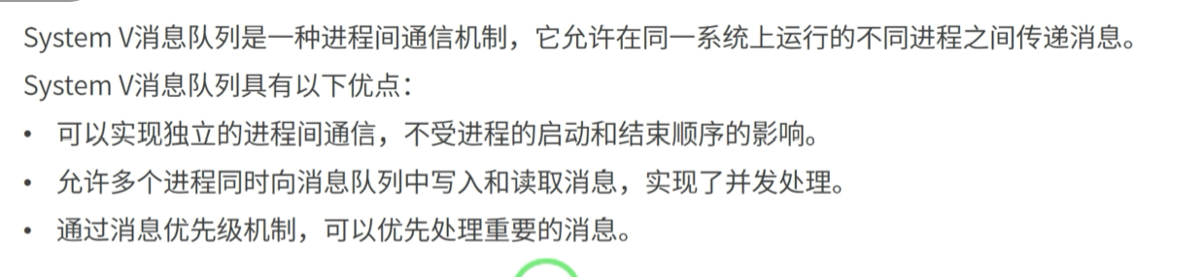  
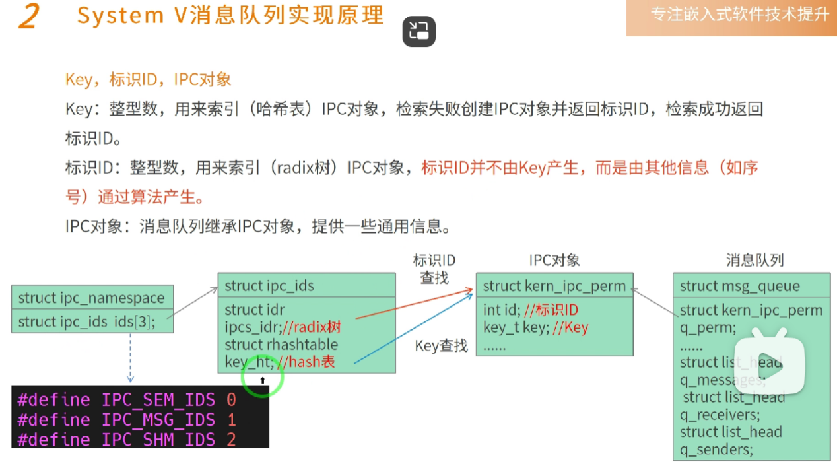

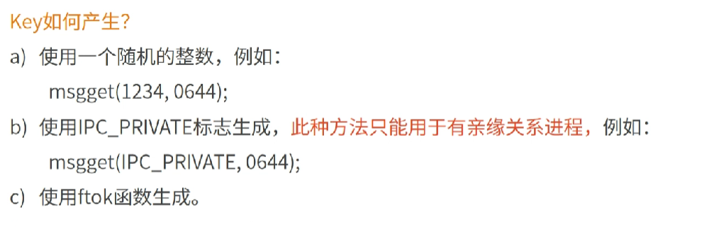

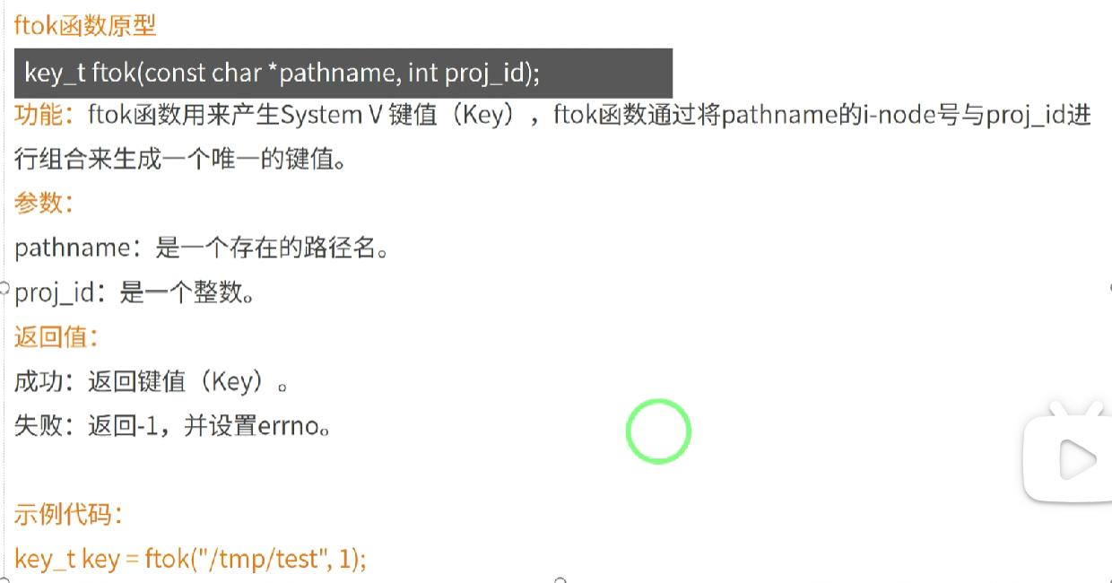

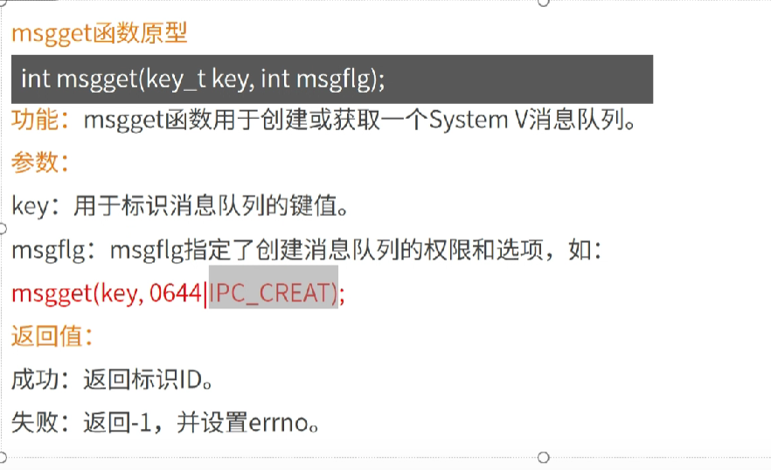

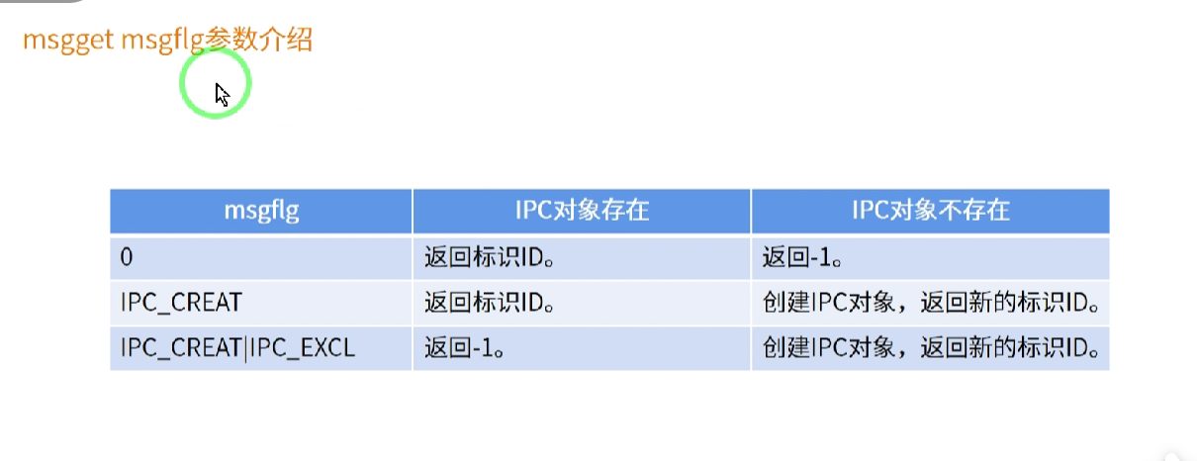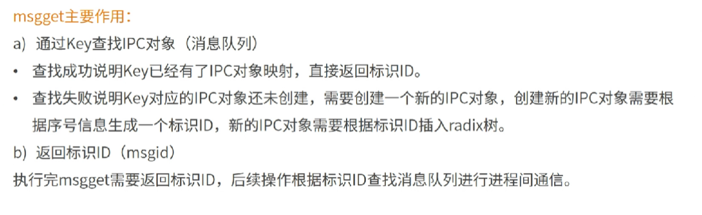

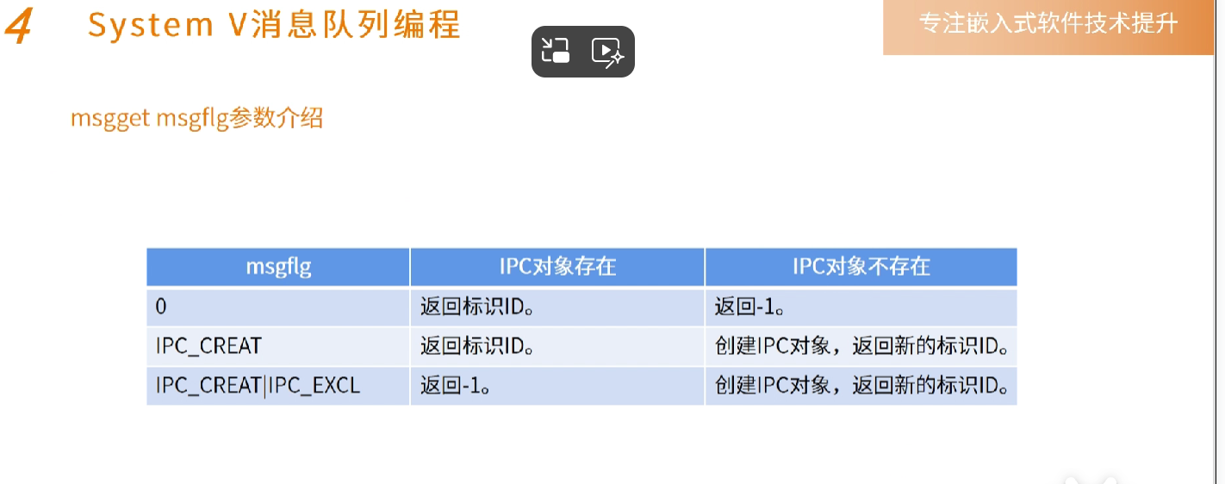

IPC_CREAT

IPC_CREAT | IPC_EXCL

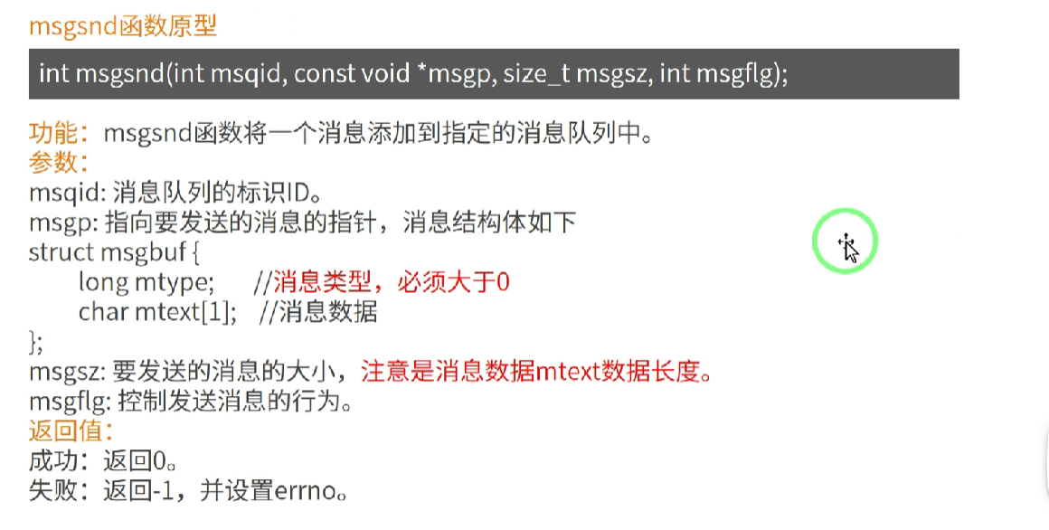

char mtext[1] 修改为 char mtext[1024]

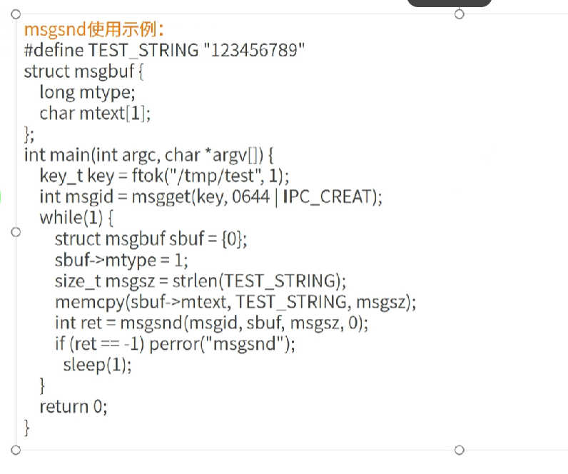

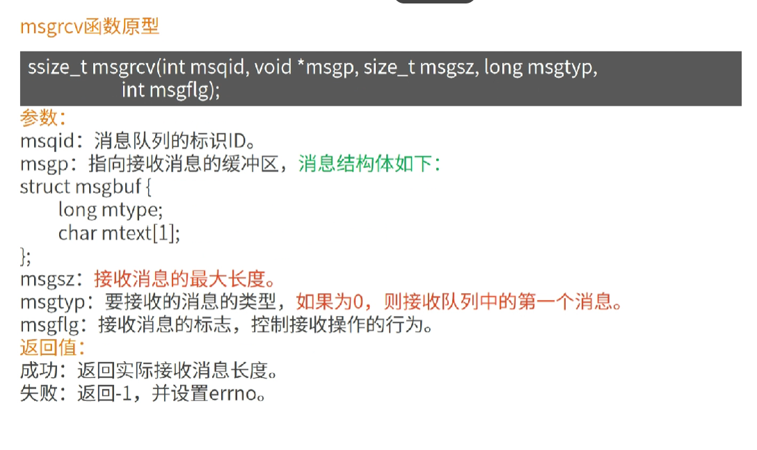

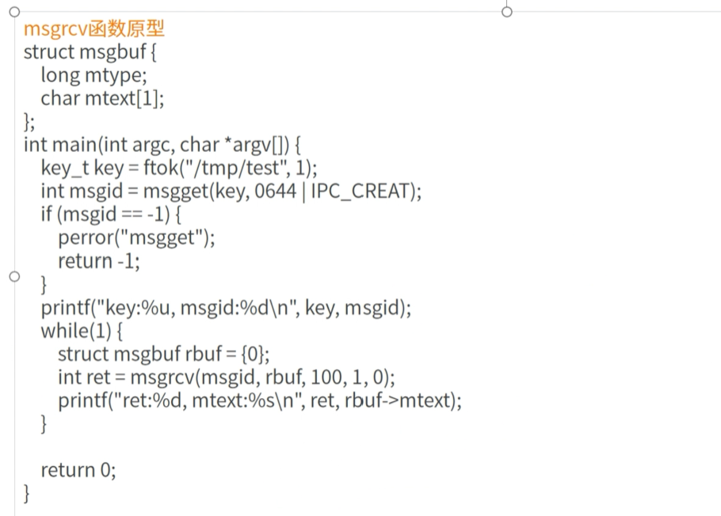

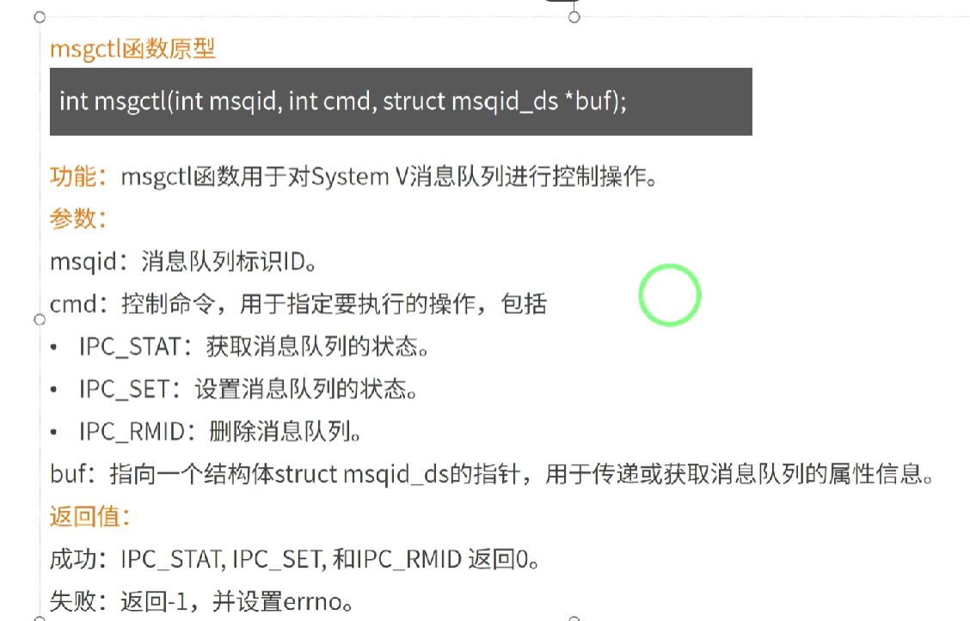

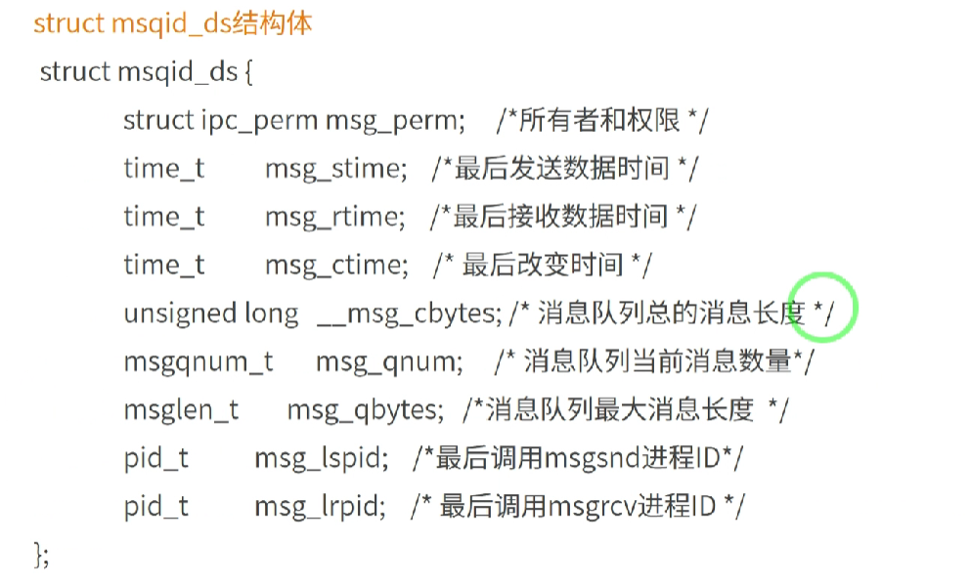

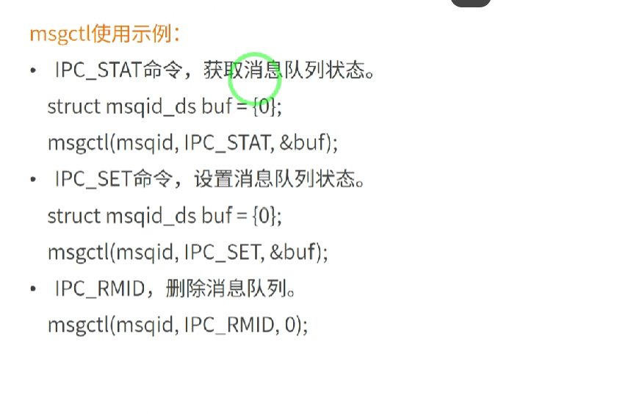  
IPC_STAT

IPC_SET

IPC_RMID

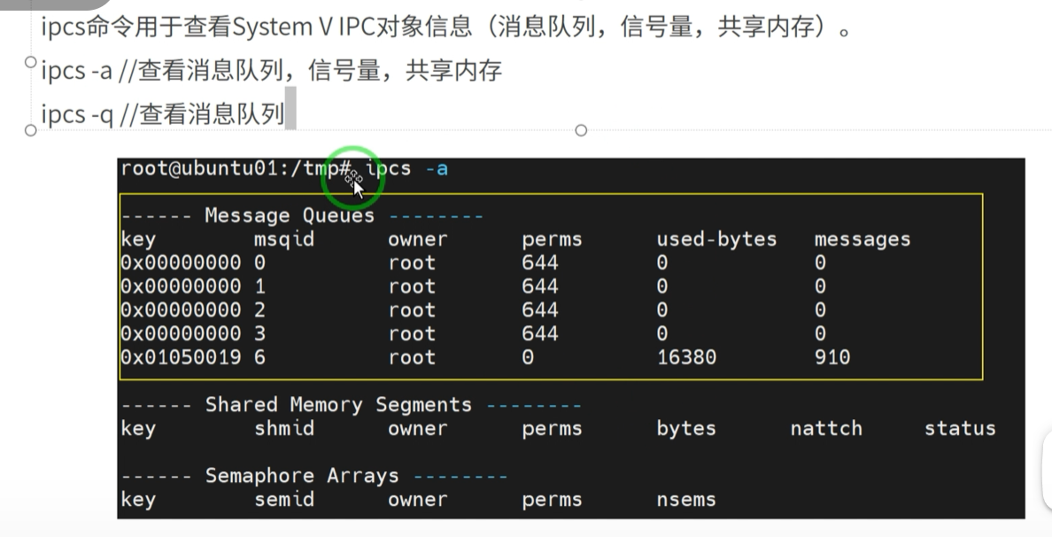

Ipcs -a

Ipcs -q

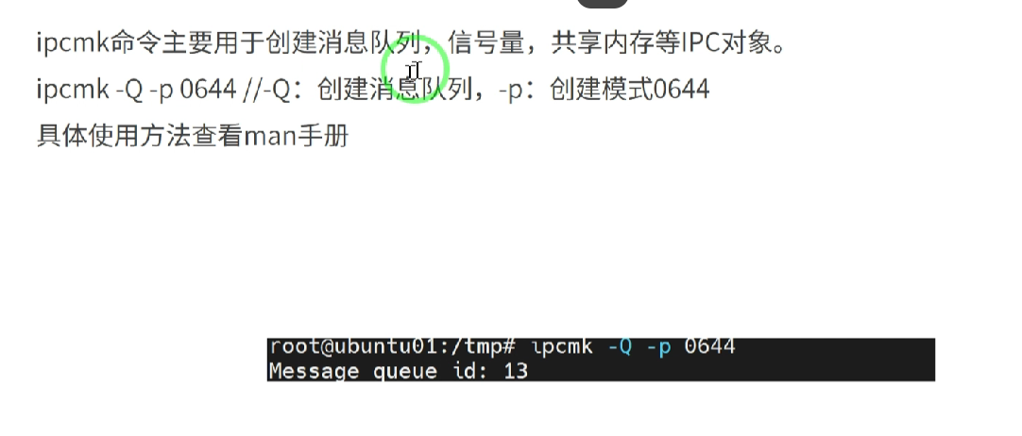

Ipcmk

Ipcmk -Q -p 0644

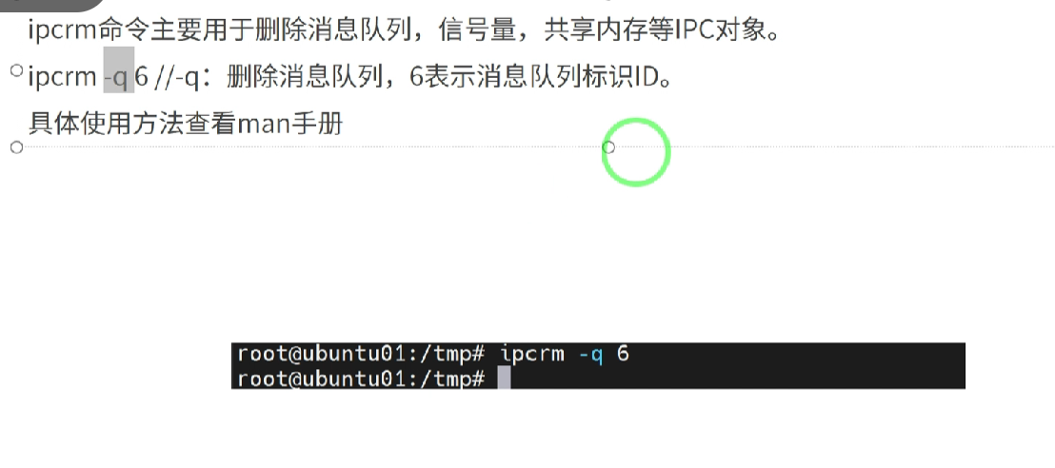

Ipcrm

Ipcrm -q 6

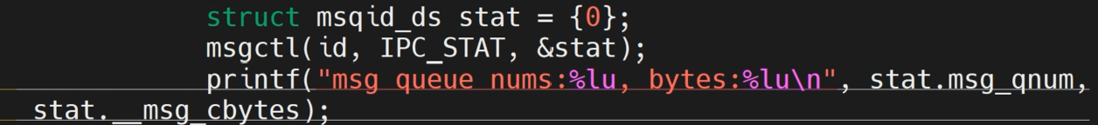

Struct msqid_ds stat = {0};

msgctl(id,IPC_STAT,&stat);

Printf(“msg queue nums : %lu ,bytes:%lu\n”,stat.msg_qnum,stat.__msg_cbytes);